**TBDR Excel Upload Guide**

* Before uploading the excel file :
* Insert all the drugs associated with the data set (Data Maintenance -> Drugs -> Add Data)
* Insert the relevant data source (Data Maintenance -> Data Source -> Add Data)
* Excel data should be inserted in the following order.

1. Variant position genome start
2. Variant position genome stop
3. Var. type
4. Number
5. WT base
6. Var. base
7. Region
8. Gene ID
9. Gene Name
10. Gene start
11. Gene stop
12. Gene length
13. Dir.
14. WT AA
15. Codon nr.
16. Codon nr. E. coli
17. Var. AA
18. AA change
19. Codon change
20. Variant position gene start
21. Variant position gene stop
22. Antibiotic
23. Reference PMID
24. High Confident
25. Remark

* 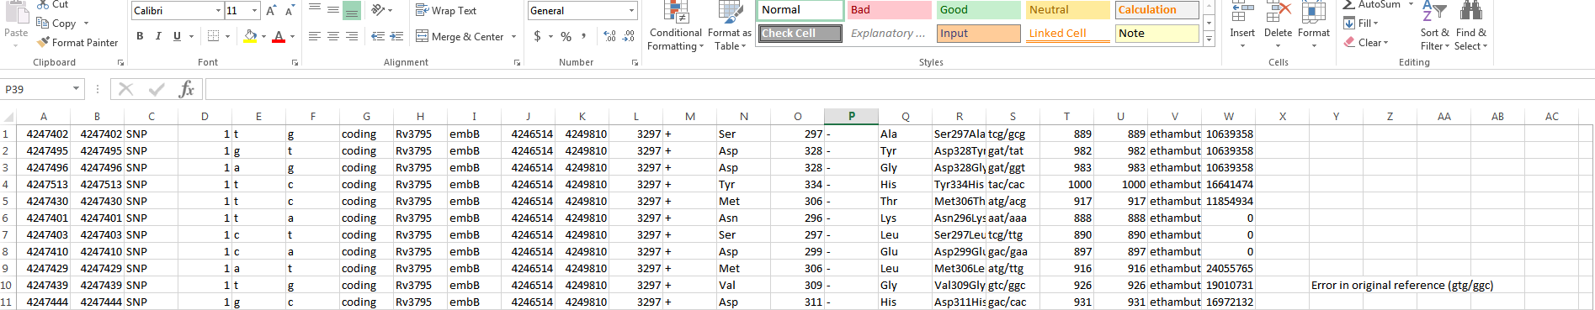When uploading the excel file make sure to delete the header row. The first record should start from 1st cell itself as shown in the example.
* If there’s no data, **Codon nr./ Codon nr. E. coli** should consists with a single dash (-) and **Reference PMID** can either have a dash (-) or a zero (0).
* No need to change anything in the excel file except the ones mentioned above. But do not leave **Var. Position Genome Start, Var. Position Genome Stop** or **Var. base** empty as it represents the primary key of the variants table and will cause the uploading process to terminate abruptly.
* Excel file must consists with 25 columns. Anything more/less will be subjected to fail the uploading process.

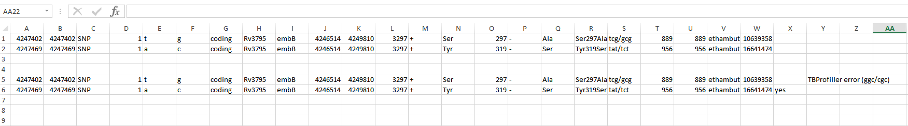

Both formats are correct

**Database Credentials**

User : **tbdr** / PW: **tbdr_123_db**

To access the db : **mysql –u tbdr –p** (press enter and key in the password)

Use tbdr;

To select records:

Select * from variants; / select * from drug_resistance;

To delete records:

First delete records from the drug_resistance table and proceed on deleting the records in the variants.

1. delete from drug_resistance;
2. delete from variants;